### Planning Proposal – 220 Ulan Road Mudgee

|  |
| --- |
| REPORT BY manager strategic planning to 1 May council meeting  Planning Proposal 220 Ulan Road  A0420258 |

RECOMMENDATION

That:

1. the report by Manager Strategic Planning on the Planning Proposal – 220 Ulan Road Mudgee be received;

2. Council prepare an amending Local Environmental Plan for 220 Ulan Road to provide for residential development;

3. the Planning Proposal under section 55 of the Environmental Planning and Assessment Act for 220 Ulan Road Mudgee be forwarded to the Department of Planning and Infrastructure seeking a Gateway Determination;

4. a further report be presented to Council upon the completion of the exhibition addressing any submissions.

Executive summary

The purpose of this report is to resolve to prepare an amending LEP for land at 220 Ulan Road Mudgee being Lot 1 DP 1000182 (refer Figure 1 below). The Planning Proposal (PP) has been prepared by Minespex on behalf of Mr Des Kennedy to amend the Mid-Western Regional Local Environmental Plan 2012 (LEP 1012) Lot Size Map to facilitate subdivision to a minimum of 2000m2.

**Figure 1 Subject Site**

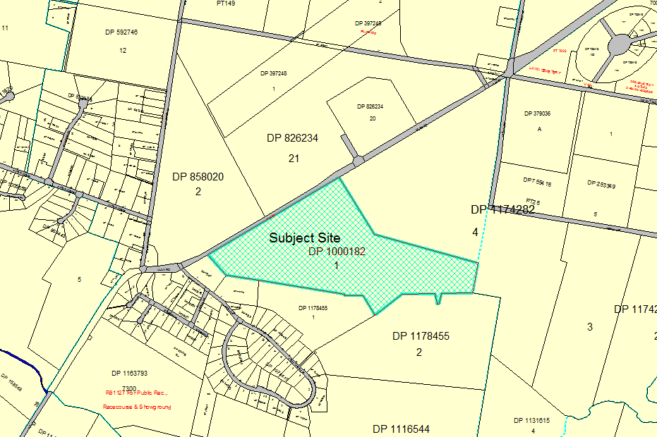

Detailed report

Council adopted a Comprehensive Land Use Strategy (CLUS) which was endorsed by the Department of Planning and Infrastructure in August 2011. The CLUS acknowledged the site as having potential for future large lot residential development and was subsequently zone R2 Low Density Residential in the LEP 2012.

Unprecedented growth in the resources sector, in particular mining, has placed enormous pressure on the local housing market to a point where demand for vacant residential land is outstripping supply. A Local Services Assessment commissioned by the state government reports that the region could see the population increase to 33,100 by 2030 and result in a lot deficiency of 1200 in 2021 and 3896 in 2030. While this is the high growth scenario, there is no doubt that there will continue to be pressure on the property market above historic growth rates. This issue has been address to some extent by Planning Proposals for the Caerleon precinct (set to deliver around 1000 residential lots of various sizes), Saleyards Lane Planning Proposal (350-400 lots to 600m2) and Bellevue Road (35 lots to 600m2).

The Planning Proposal before Council has been prepared for Lot 1 DP 1000182 and will increase the residential yield of the site by 64 lots to 136 lots. The concept plan (below) includes a range of lot sizes from 6000m2 to 2000m2 and includes opportunities for connectivity with adjoining land. The proposal fronts Ulan Road, however access in limited to a single point and a lot configuration that ensure that development of the site can be undertaken having regard to the visual impact of on Ulan Road. The development is proposed to be completed in 6 stages of between 19 and 36 lots (indicative).

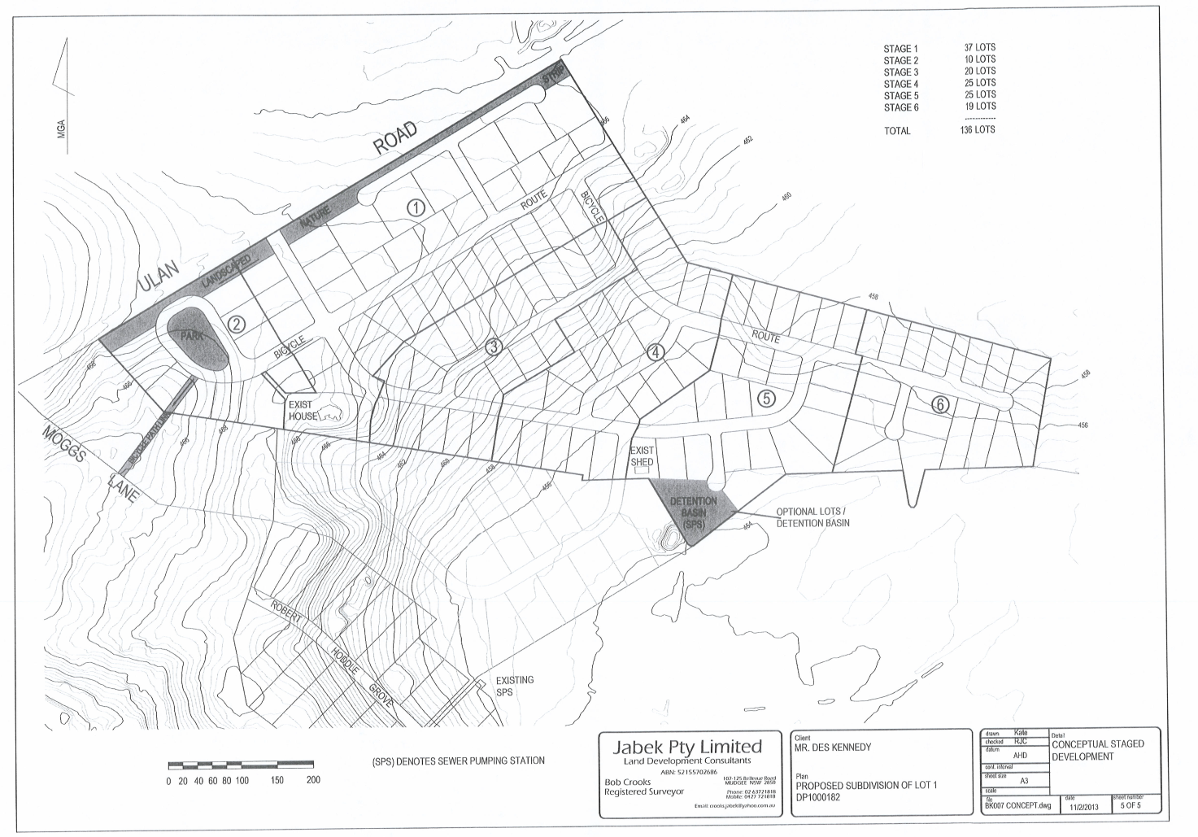

The land is currently zoned R2 Low Density Residential with a minimum lot size of 4000m2. The PP does not propose to amend the zone, rather reduce the minimum subdivision size from 4000m2 to 2000m2.

The proposal includes:

* A concept plan a lot layout (above)
* An area for a detention basin and SPT for stages 4-6
* Open space
* Pedestrian/cycle link to Moggs Lane
* Connectivity through the site to accommodate orderly development of adjoining zoned land.

**Servicing**

Water and sewer are available and the site can be connected to the town water and sewer reticulation systems. A indicated above, states 4-6 will require the installation of a sewerage pump station.

Reticulated water is available through the existing water reticulation system for both this site and the potential for another 170 on adjoining land in the future but not within the current levels of service adopted by Council without augmentation of the existing supply system. The options available for water supply will need to be negotiated with the proponent at the development application stage and may result is a reduction of pressure for existing dwellings.

**Provisions**

The intended outcome of the planning proposal is to enable residential development across the precinct. The amendment to the LEP will be an amendment to the Minimum Lot Size Map to reflect a minimum lot size of 2000m2.

The detailed Planning Proposal to be submitted for Gateway Determination is Attachment 1.

Financial implications

Not applicable.

Strategic or policy implications

The planning proposal will reinforce the direction of growth as set through the Comprehensive Land Use Strategy and provide certainty in terms of the ongoing supply of residential land in the short term.

|  |  |
| --- | --- |
|  |  |
| LIZ DENSLEY  MANAGER STARTEGIC PLANNING | catherine van laeren  group manager development & Community services |

15 April 2013

*Attachments*: 1. Planning Proposal (following at the end of the Business Paper)

APPROVED FOR SUBMISSION:

|  |
| --- |
| BRAD CAM  ACTING GENERAL MANAGER |